1.

#include <stdio.h>

int main()

{

int formula(int,int);

int m,n,total;

printf("Enter the m:");

scanf("%d",&m);

printf("Enter the n:");

scanf("%d",&n);

total=formula(m,n);

printf("The number of %d proplrthat can br created from a pool created a pool of %d people is %d",n,m,total);

return 0;

}

int formula(int m,int n)

{

int i,j,k;

int t=1,p=1,q=1;

for(i=1;i<=m;i++)

t\*=i;

for(j=1;j<=n;j++)

p\*=j;

for(k=1;k<=m-n;k++)

q\*=k;

return (t/(p\*q));

}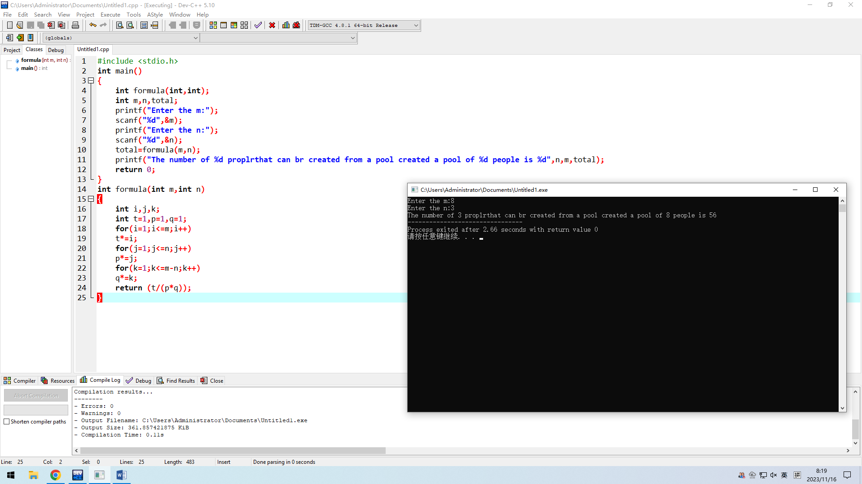

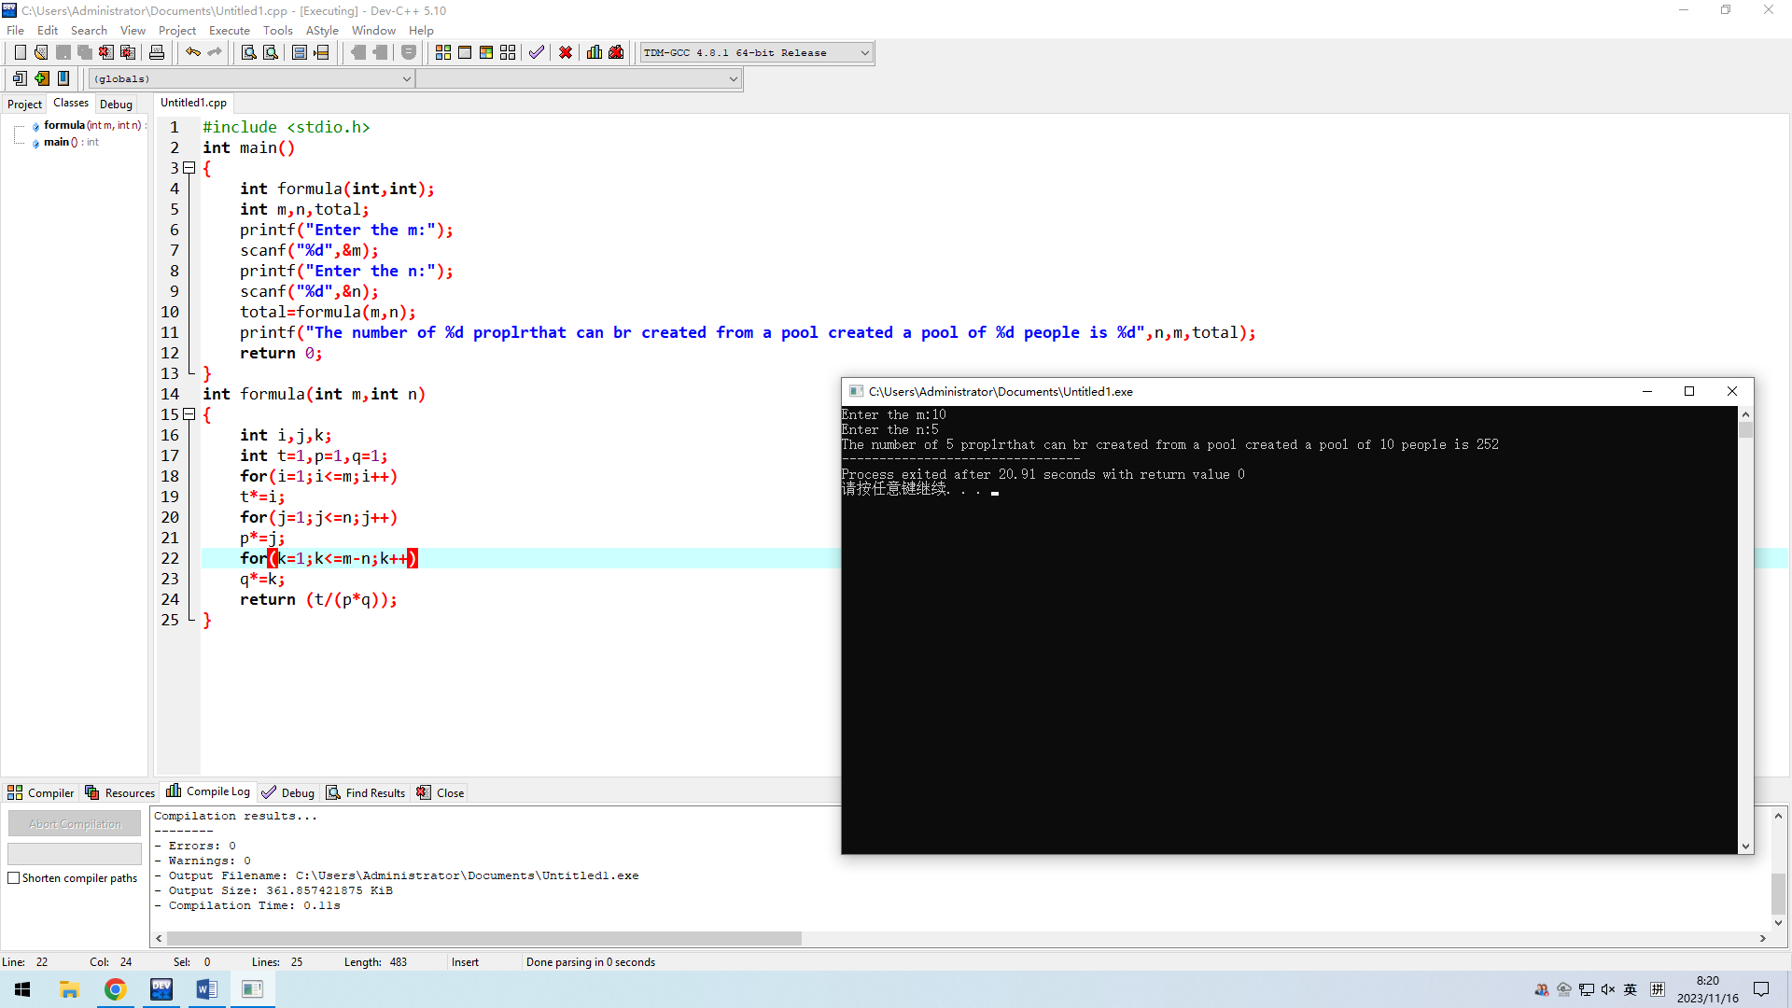

2.

#include <stdio.h>

int main()

{

double fun(double,double,double,double);

double a,b,c,x,v;

while(1)

{printf("Enetr the a,b,c,x :");

scanf("%lf,%lf,%lf,%lf",&a,&b,&c,&x);

if(a==0)

{printf("a can't be 0!\n");

continue;}

else

{v=fun(a,b,c,x);

printf("The value is :%lf",v);

break;}}

return 0;

}

double fun(double a,double b,double c,double x)

{

double v;

v=a\*x\*x+b\*x+c;

return v;

}

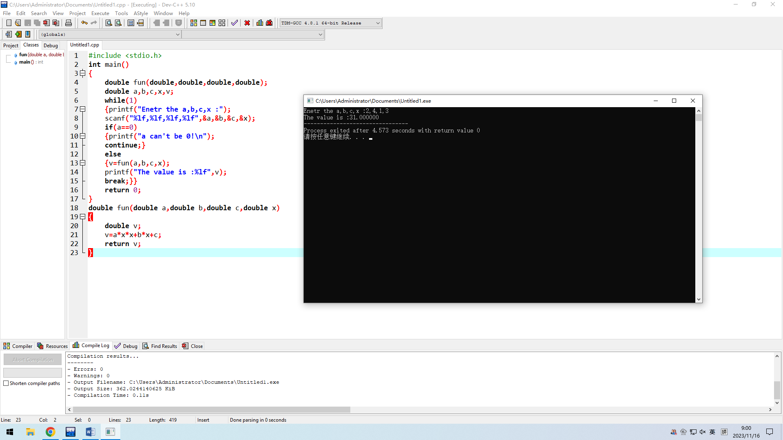

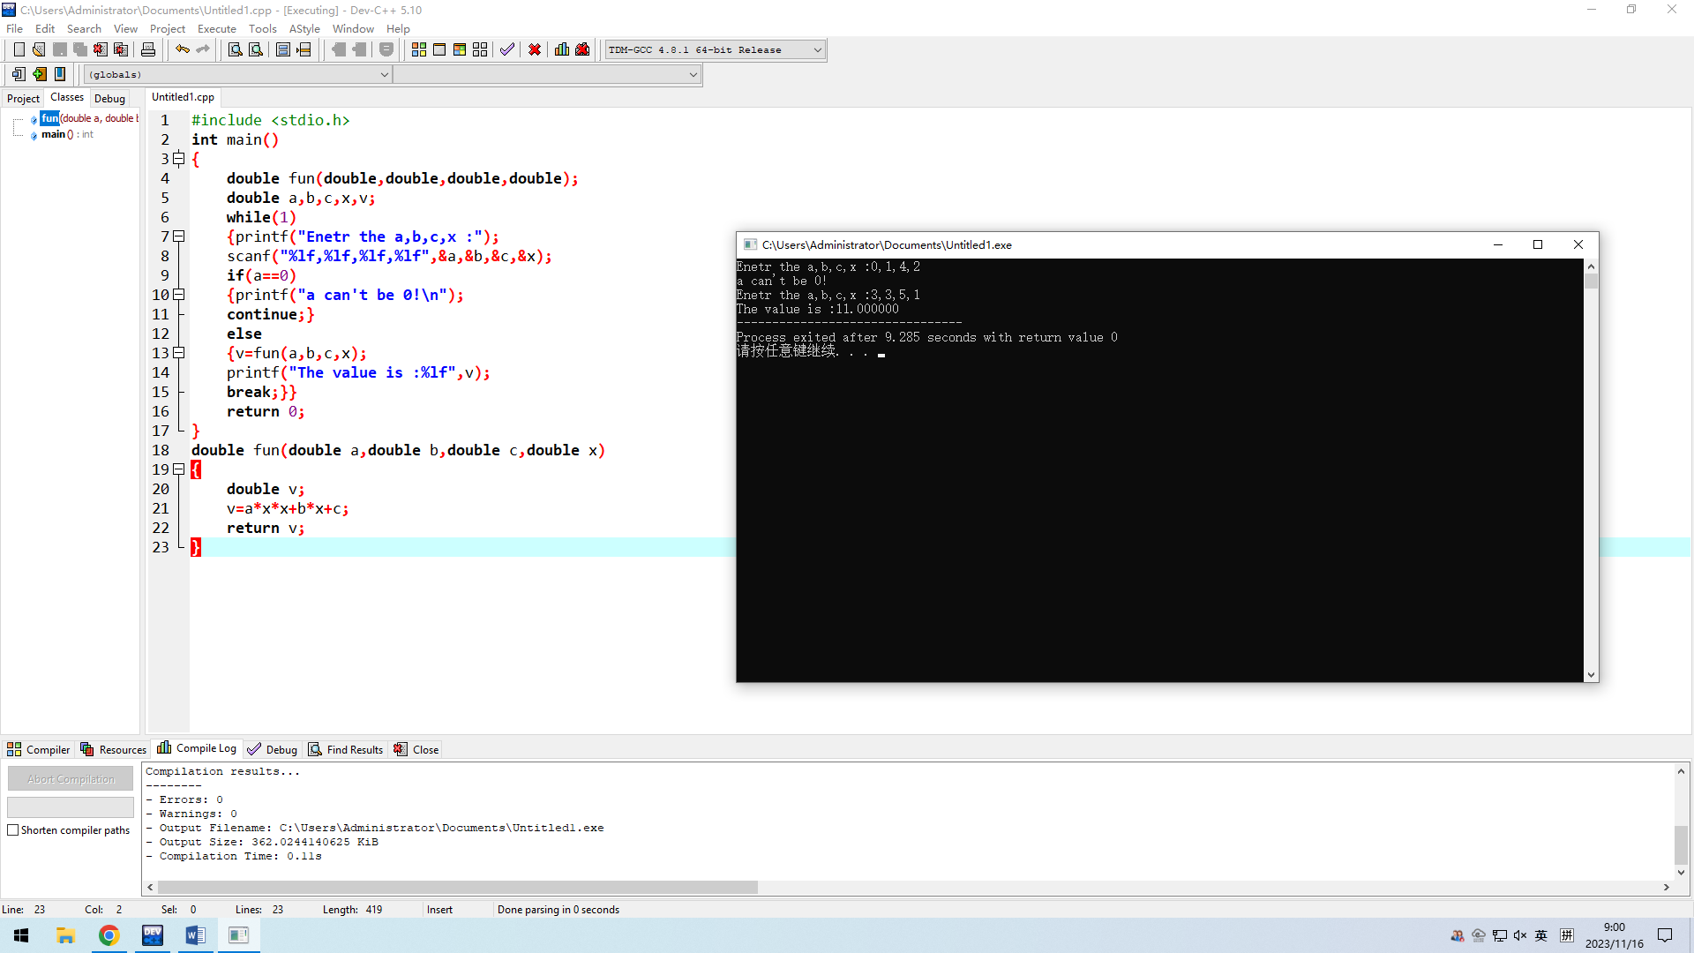

3.

#include <stdio.h>

#define PI 3.1415926

int main()

{

double fun(double);

double a,c;

printf("Enter the circumference ：");

scanf("%lf",&c);

a=fun(c);

printf("The area is %lf",a);

return 0;

}

double fun(double c)

{

double r,a;

r=c/(2\*PI);

a=PI\*r\*r;

return a;

}

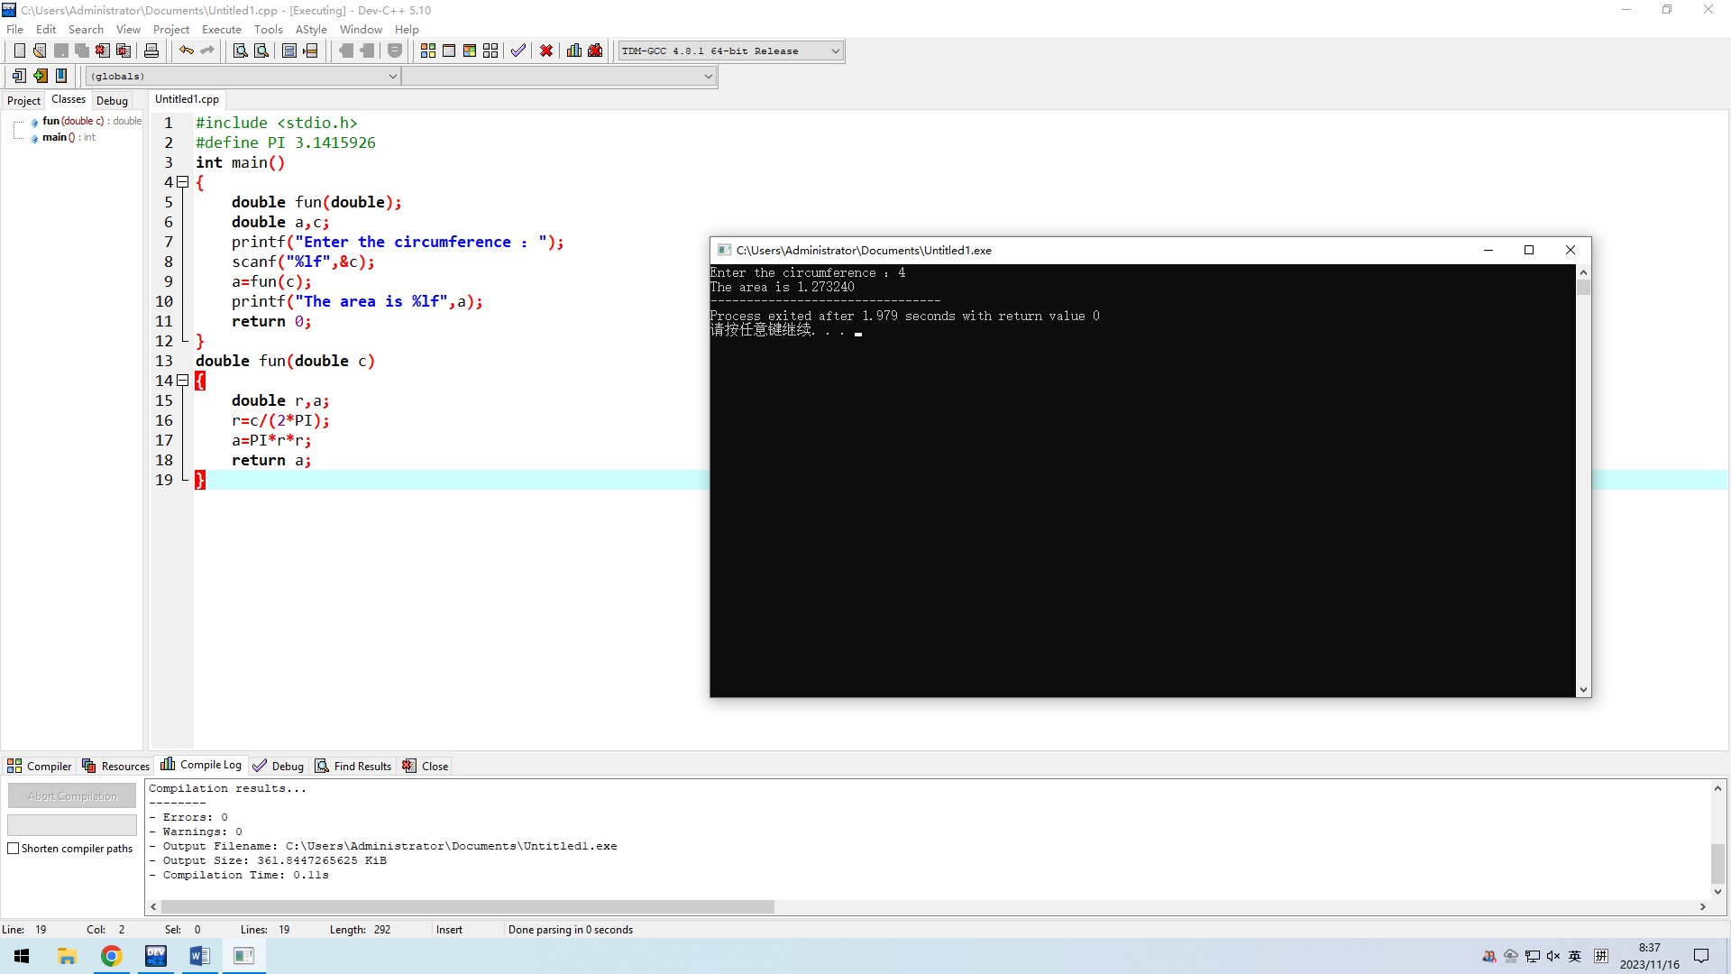

4.

#include <stdio.h>

#define PI 3.1415926

int main()

{

double fun(double,double);

double r,h,v;

printf("Enter the radius:");

scanf("%lf",&r);

printf("Enter the height:");

scanf("%lf",&h);

v=fun(r,h);

printf("The volume is %lf",v);

return 0;

}

double fun(double r,double h)

{

double v;

v=PI\*h\*r\*r;

return v;

}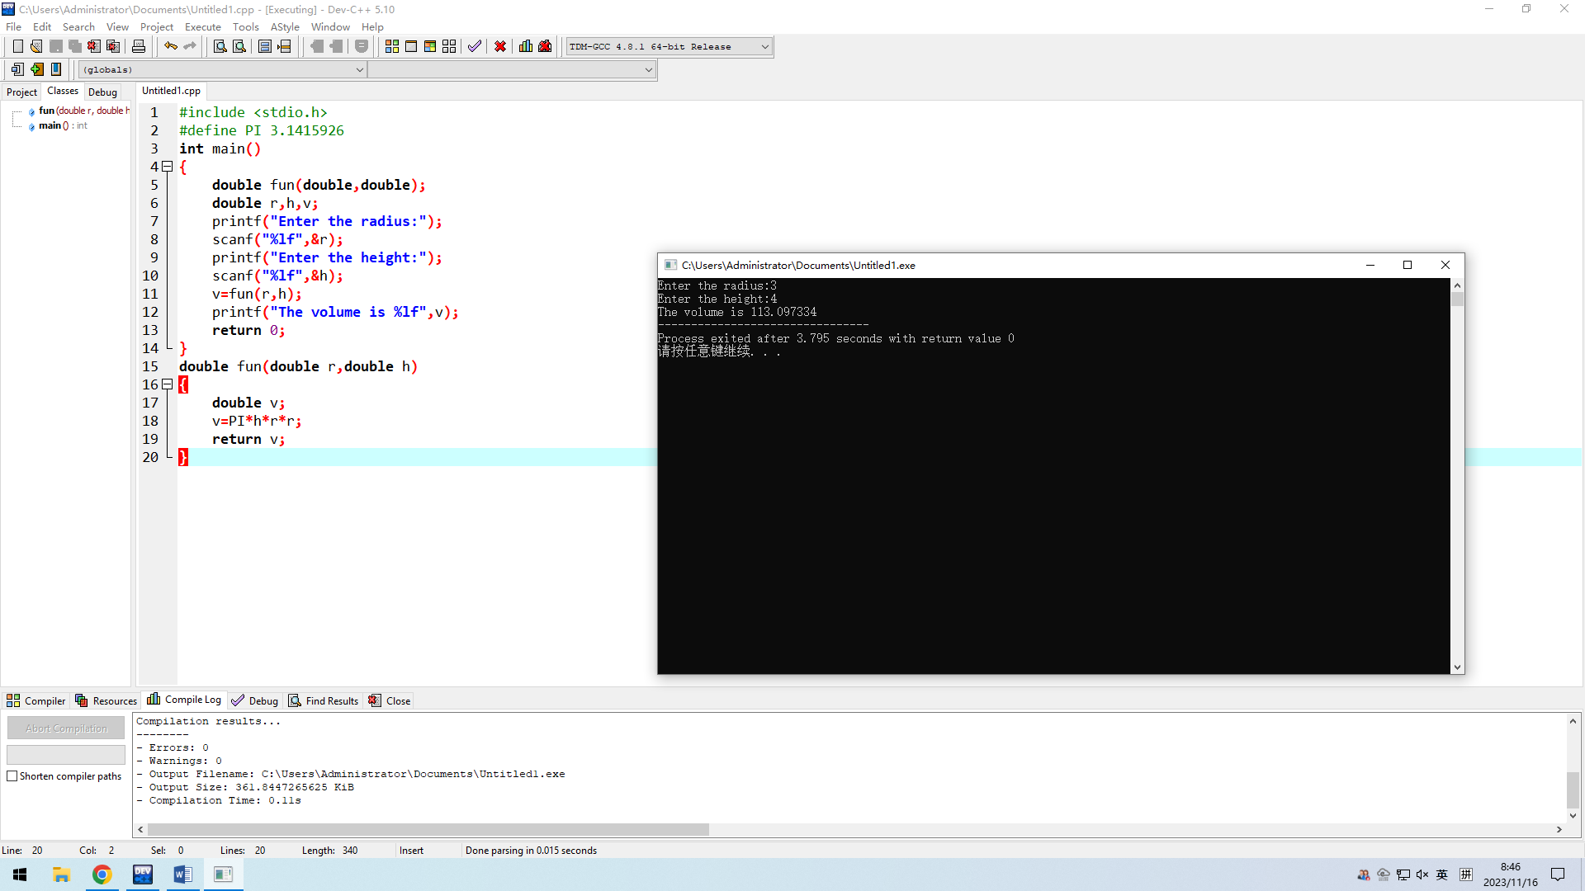

5.

#include <stdio.h>

int main()

{

double round(double,int);

double num1;

int num2;

printf("Enter the num,round:");

scanf("%lf,%d",&num1,&num2);

printf("The final number is %lf",round(num1,num2));

return 0;

}

double round(double x,int y)

{

int t=1,i;

for(i=1;i<=y;i++)

t\*=10;

x\*=t;

x+=0.5;

x=(int)x;

x=x/(double)t;

return x;

}

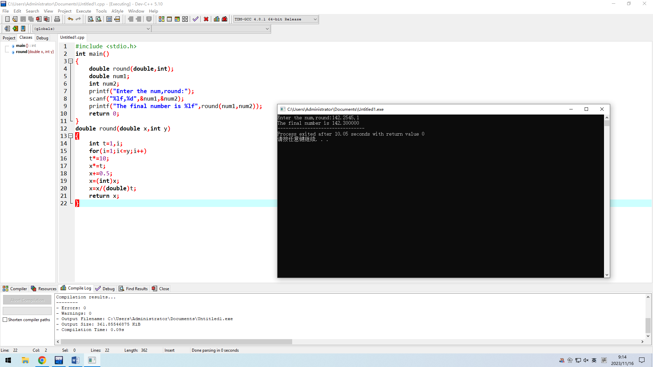

b.

#include <stdio.h>

#define RATE 0.08675

int main()

{

double round(double,int);

double num1;

int num2;

printf("Enter the num,round:");

scanf("%lf,%d",&num1,&num2);

num1=num1\*(1+RATE);

printf("The final number is %lf",round(num1,num2));

return 0;

}

double round(double x,int y)

{

int t=1,i;

for(i=1;i<=y;i++)

t\*=10;

x\*=t;

x+=0.5;

x=(int)x;

x=x/(double)t;

return x;

}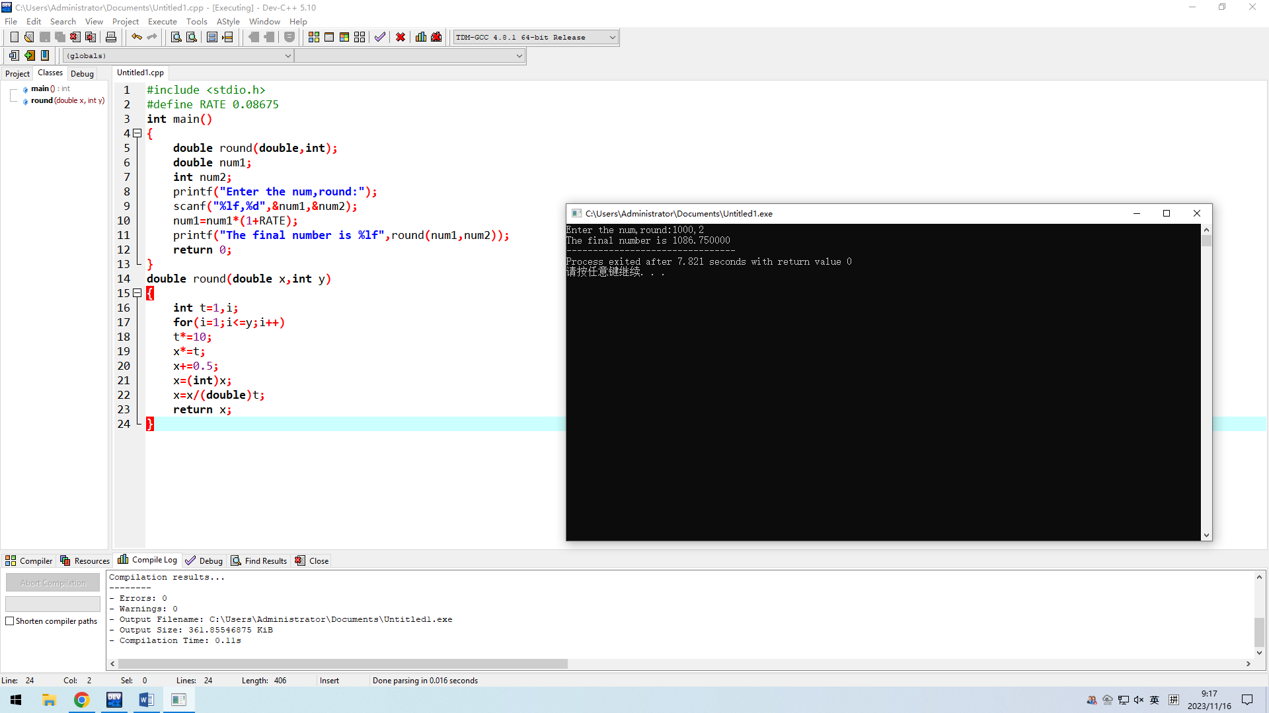

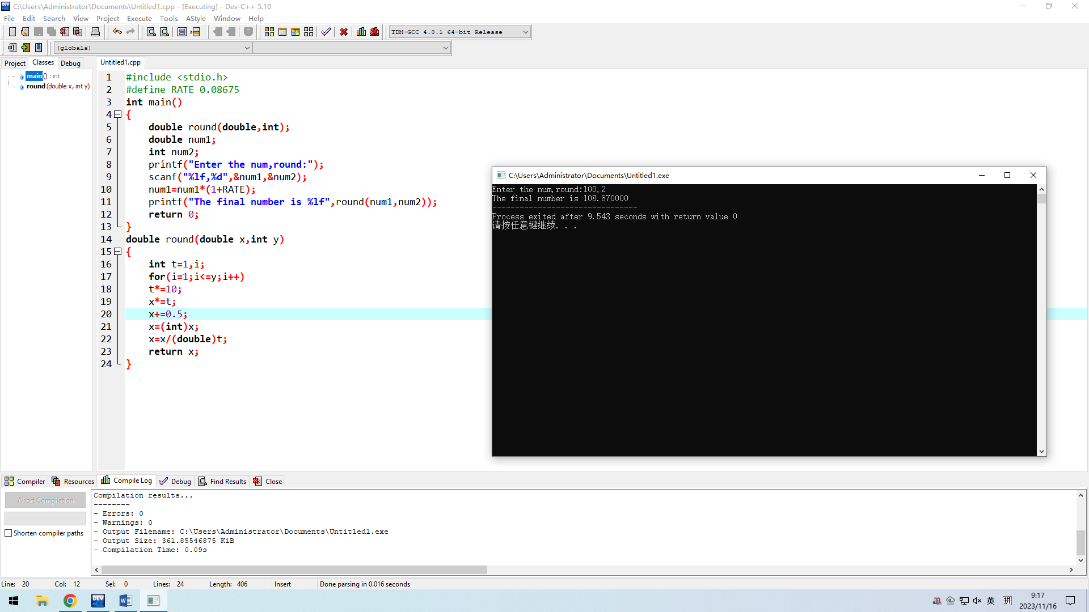

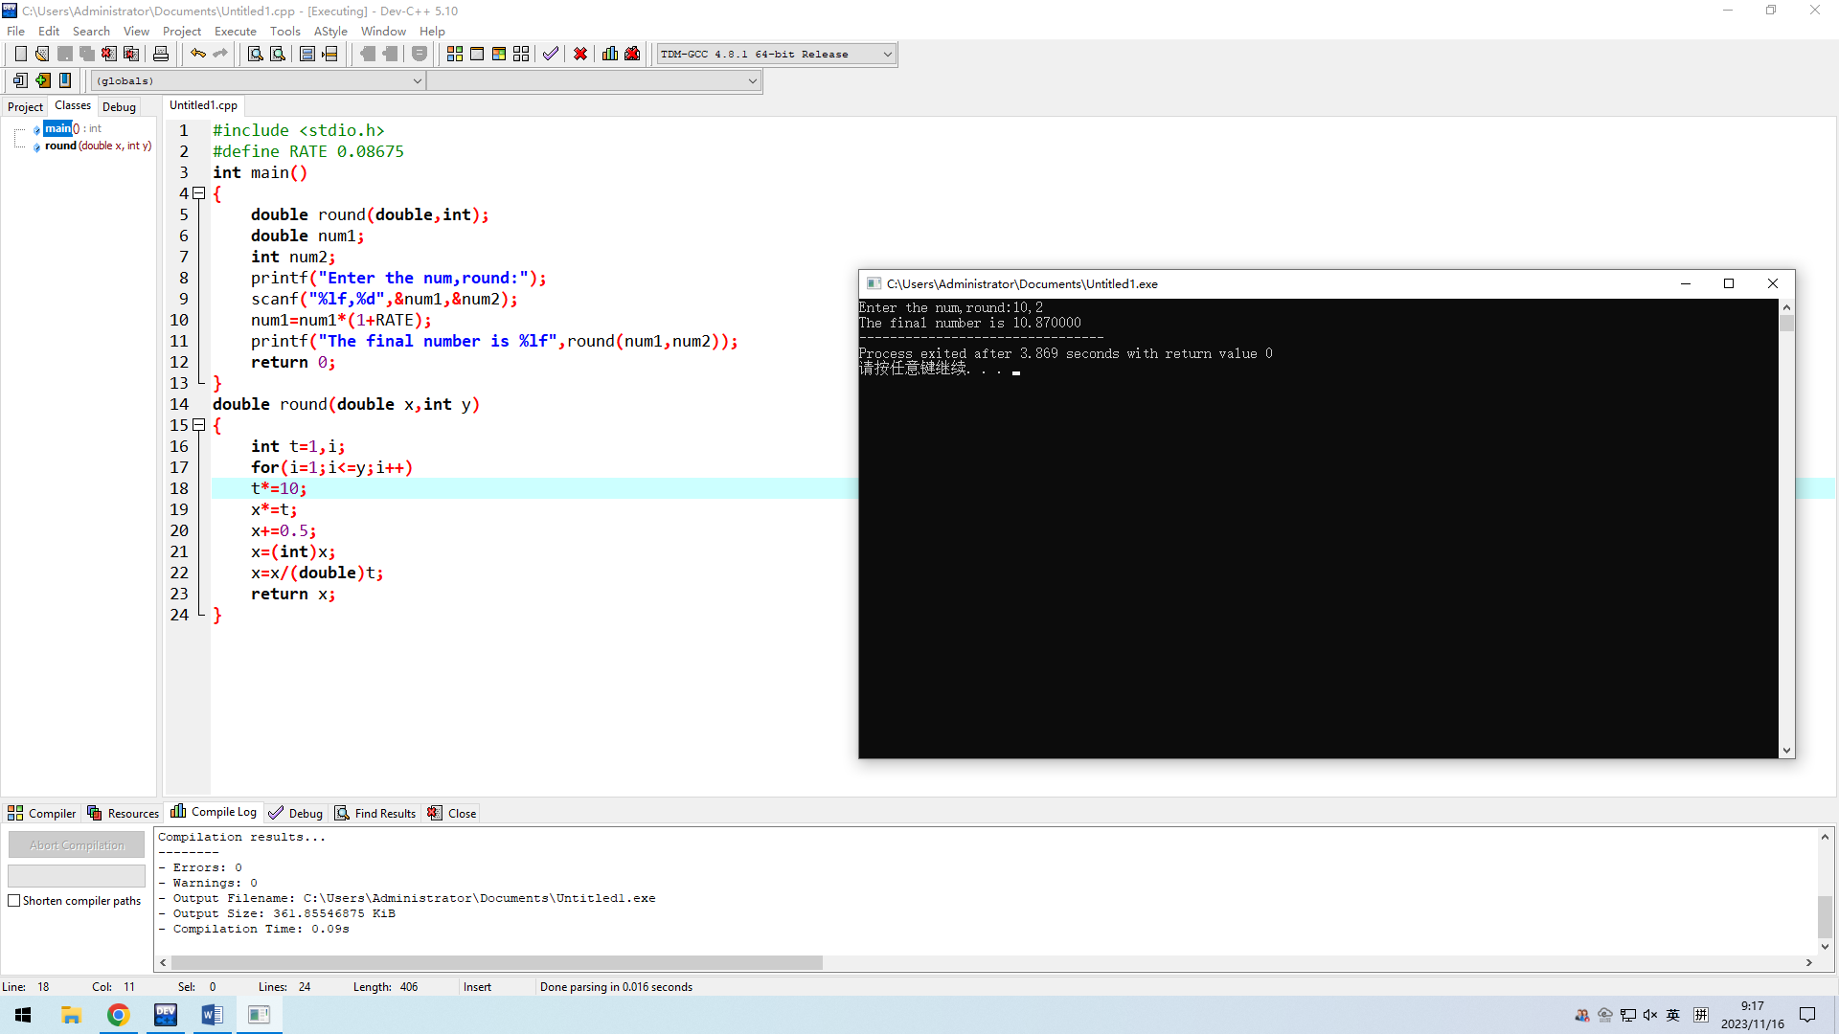

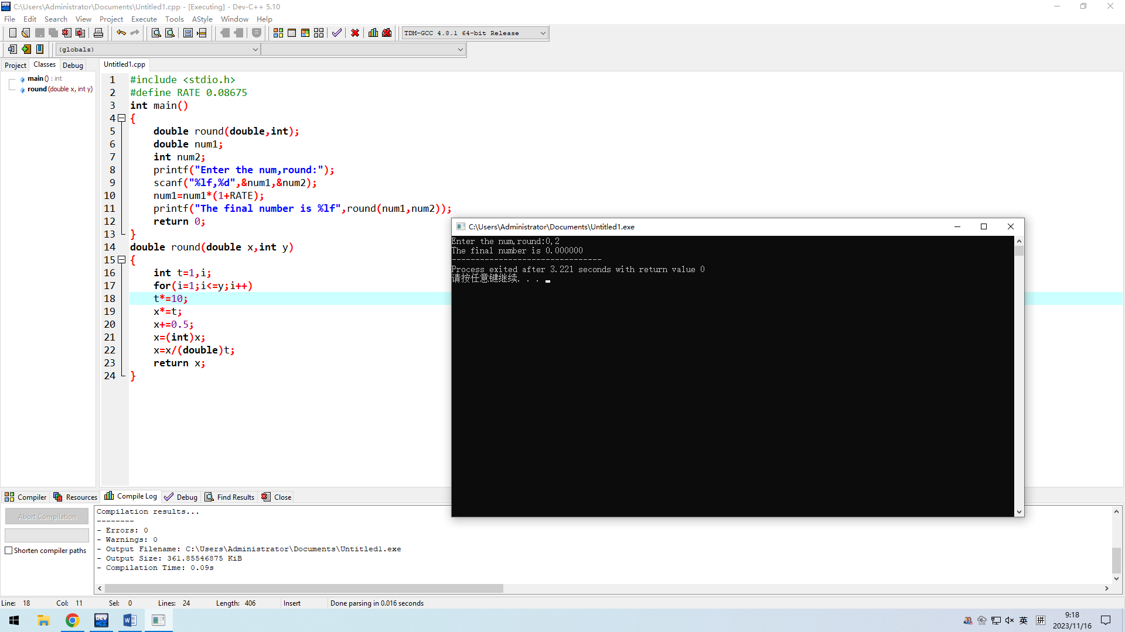

6.

#include <stdio.h>

int main()

{

int whole(double);

double num;

int n;

printf("Enter the number:");

scanf("%lf",&num);

n=whole(num);

printf("The integer part of the number is:%d",n);

return 0;

}

int whole(double x)

{

int y;

y=int(x);

return y;

}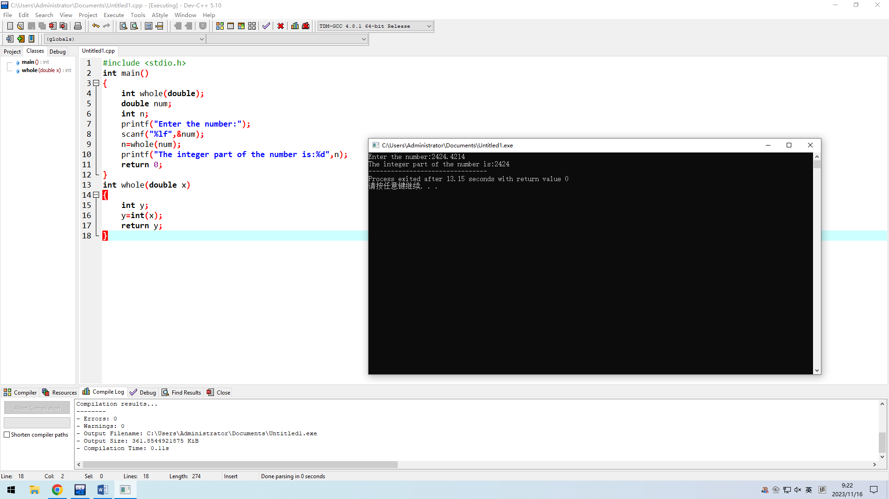

7.

#include <stdio.h>

int main()

{

int whole(double);

double fracpart(double);

double num,n;

printf("Enter the number:");

scanf("%lf",&num);

n=fracpart(num);

printf("The fractional part of the number is:%lf",n);

return 0;

}

int whole(double x)

{

int y;

y=int(x);

return y;

}

double fracpart(double num)

{

num=num-whole(num);

return num;

}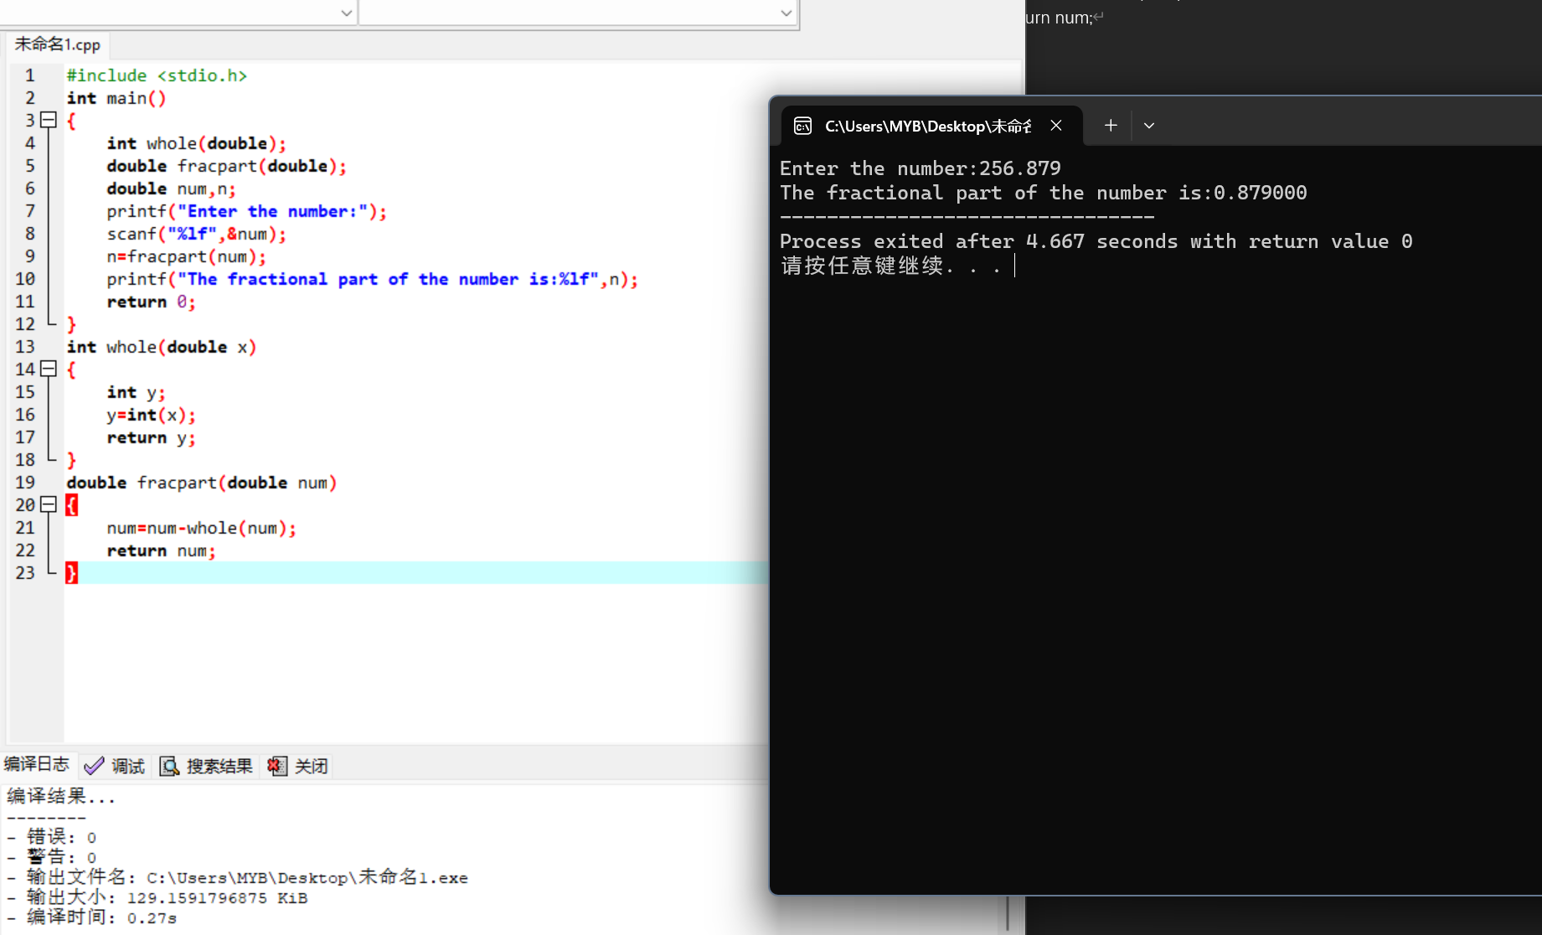

8.

#include <stdio.h>

int main()

{

double squash(int);

double lemon(int);

double raisin(int);

double applesauce(int);

double sugar(int);

double walnut(int);

int n;

printf("Enetr the num of people:");

scanf("%d",&n);

printf("Each ingredient:%lfacorn squashes %lfteaspoons of lemon juice %lfcup of raisins",squash(n),lemon(n),raisin(n));

printf("%lfcups of applesause %lfcup of brown sugar %lftablespoons of chopped walnuts",applesauce(n),sugar(n),walnut(n));

return 0;

}

double squash(int n)

{

return ((2.0/4)\*n);

}

double lemon(int n)

{

return ((2.0/4)\*n);

}

double raisin(int n)

{

return (((1.0/4)/4)\*n);

}

double applesauce(int n)

{

return (((3.0/2)/4)\*n);

}

double sugar(int n)

{

return (((1.0/4)/4)\*n);

}

double walnut(int n)

{

return ((3.0/4)\*n);

}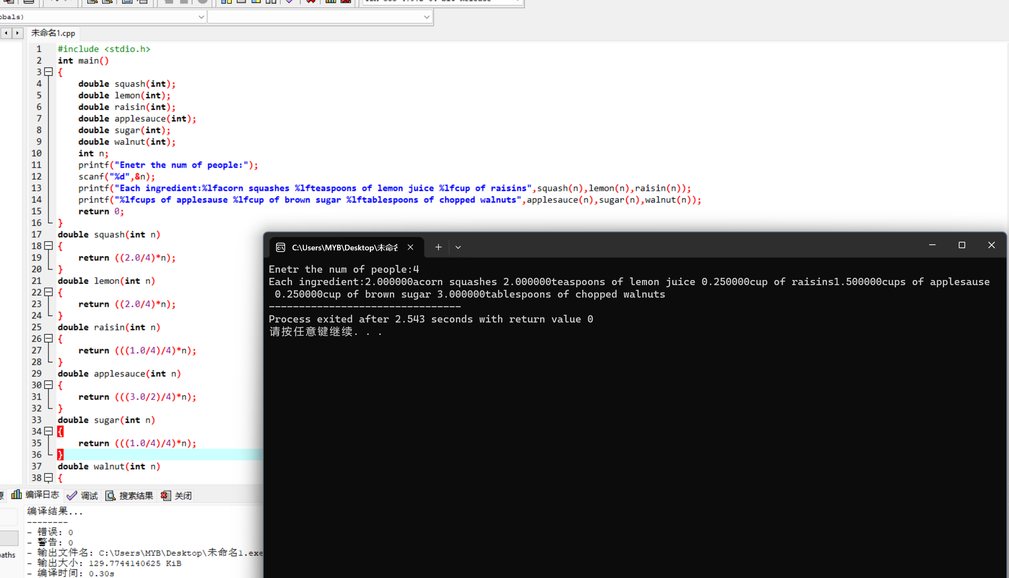

9.

#include <stdio.h>

int main()

{

double straw(int,int);

int n,p,o,t;

printf("Enter the number of students:");

scanf("%d",&n);

printf("\nEnter the total pounds adds ounces:");

scanf("%d,%d",&p,&o);

t=p\*16+o;

printf("\nEach student receives :%lf ounces",straw(n,t));

return 0;

}

double straw(int n,int t)

{

double e;

e=(t/2.0)/n;

return e;

}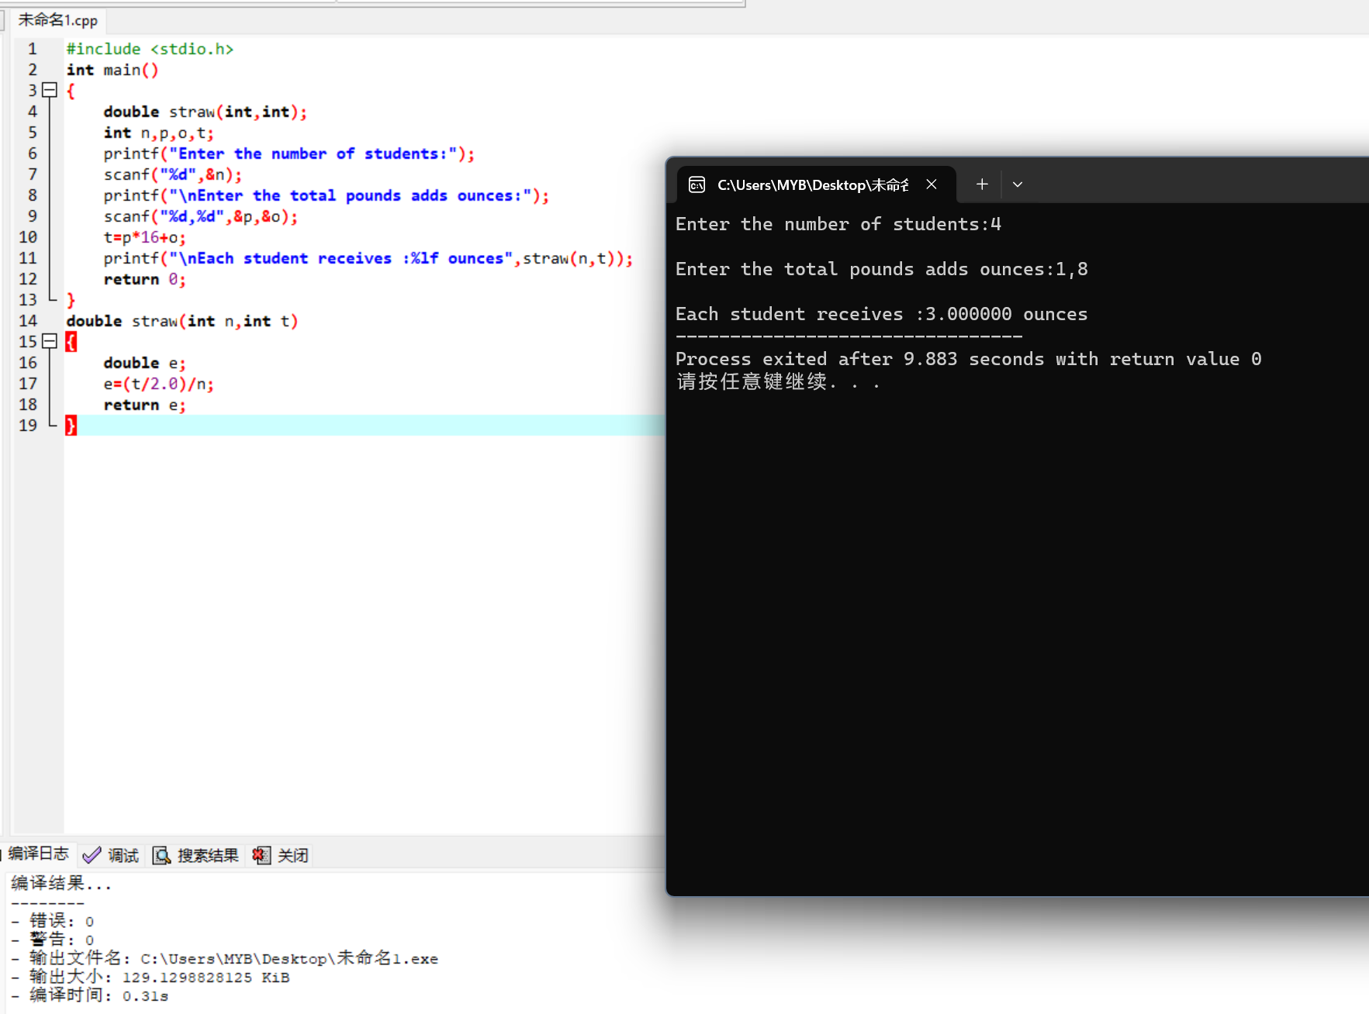

10.

#include <stdio.h>

#include <stdlib.h>

#include <time.h>

int flip(int);

void percentages(int,int);

int main()

{

int num;

printf("Enter the numTosses:");

scanf("%d",&num);

int heads;

heads=flip(num);

percentages(num,heads);

return 0;

}

int flip(int num)

{

int randValue;

int heads=0;

int i;

srand(time(NULL));

for(i=1;i<=num;i++)

{

randValue=1+(int)rand()%100;

if(randValue>50)

heads++;

}

return (heads);

}

void percentages(int num,int heads)

{

int tails;

float perheads,pertails;

if(num==0)

printf("There were no tosses,so no percentage can be calculated.\n");

else

{

tails=num-heads;

printf("Number of coin tosses:%d\n",num);

printf("Heads:%d Tails:%d\n",heads,tails);

perheads=(float)heads/num\*100.0;

pertails=(float)(num-heads)/num\*100.0;

printf("Heads came up %6.2f percent of the time.\n",perheads);

printf("Tails came up %6.2f percent of the time.\n",pertails);

}

}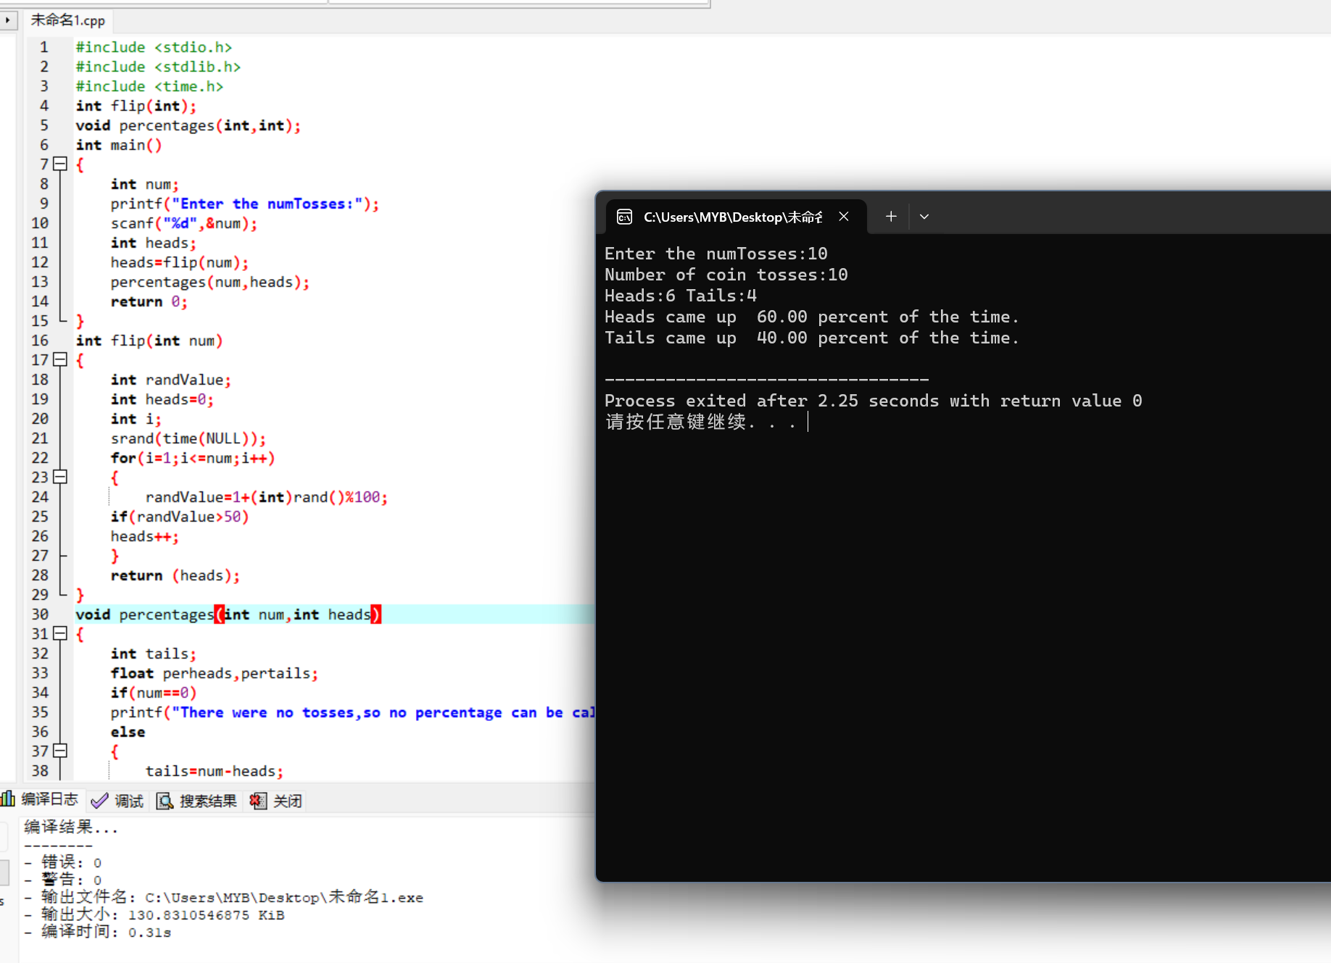

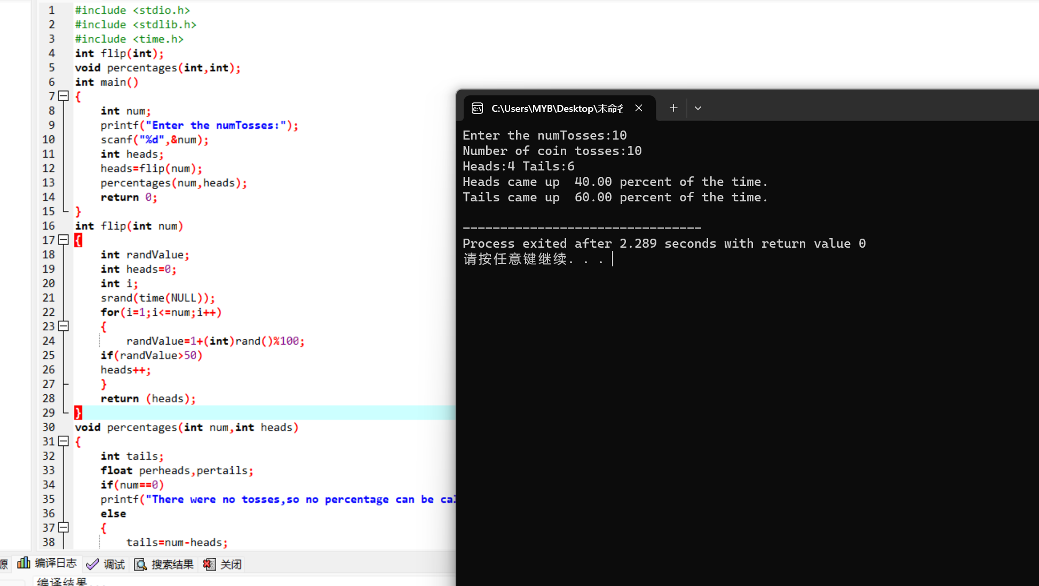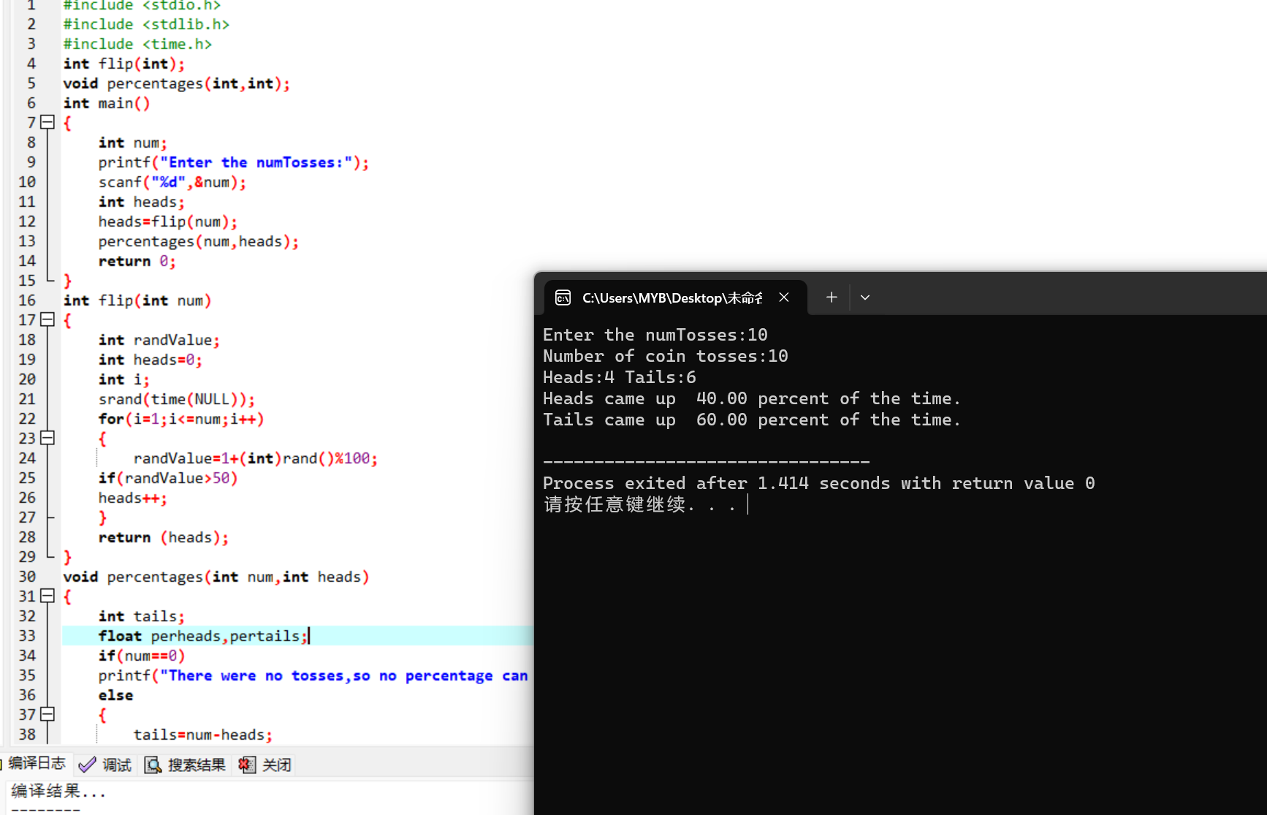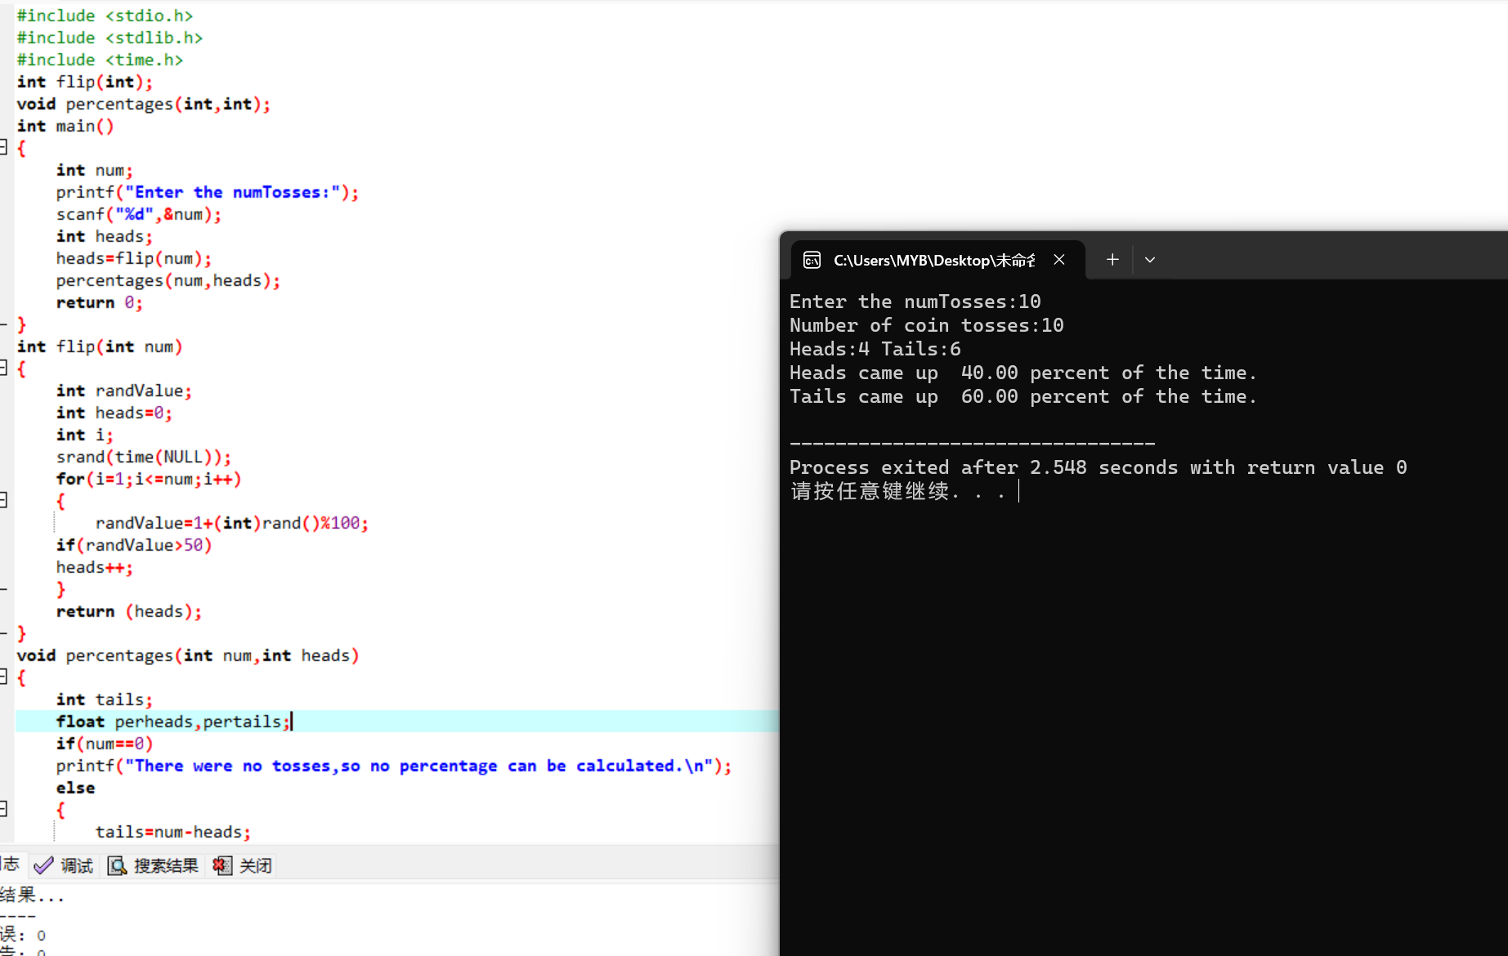

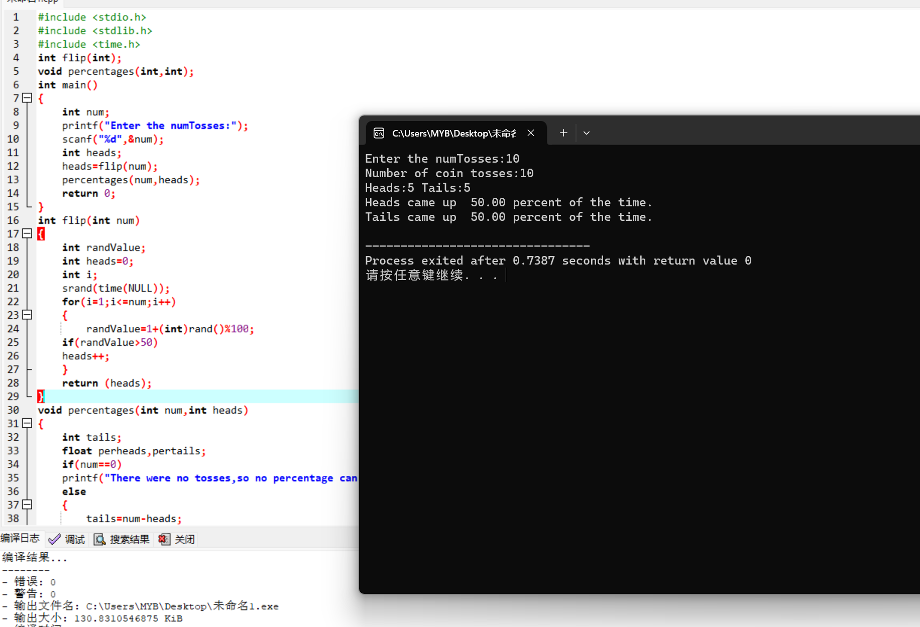

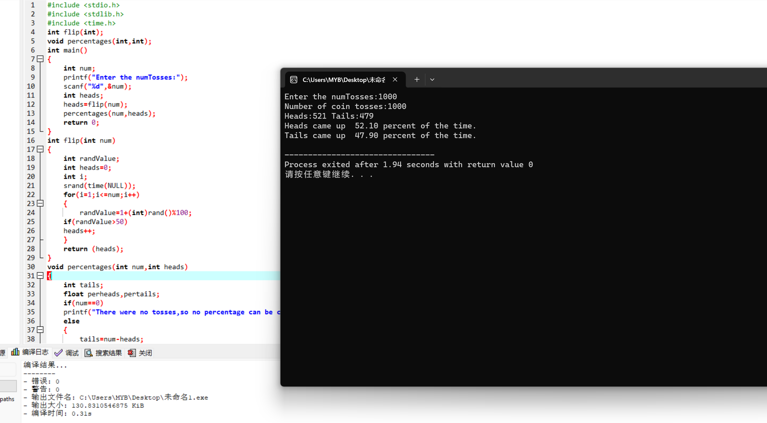

b.有区别，